**Game Design Document – 2D-Unity-Project**

**Student Card Number:** 10631028

**GitHub Repository**: <https://github.com/caleb-long19/The-Quest-For-Orion-s-Flower>

**Trello**: <https://trello.com/b/aG4i8prK/soft166-unity-project-the-quest-for-orions-flower>

**Itch.io Game Page**: <https://cwispy.itch.io/the-quest-for-orions-flower>

**Game Name:** The Quest for Orion’s Flower

**Game Story**

You Play as Isaac, a young man who helps his family around the house. After learning about his family’s curse, he sets out on a Quest to find Orion’s Flower. A Flower with the ability to grant you a wish of your choosing. In order to get to it, he must fight through multiple Dungeons and collect 3 Temple Orbs. Once he has all 3, he can enter the Ancient Temple and Retrieve the Flower!

|  |  |  |
| --- | --- | --- |
| **Character 1 – Clark (Player)** | | |
| Appearance | Character Backstory | Stereotypes |
|  | Clark is a young man who lives with his family. One day Clark’s Mother and Father told him about the curse that is bound to the family. Clark takes it upon himself to go on a quest to find Orion’s Flower and break the family curse and set them free. | * Hero * Brave |

|  |  |  |
| --- | --- | --- |
| **Character 2 – Dad (NPC)** | | |
| Appearance | Character Backstory | Stereotypes |
|  | Clark’s Father tries his best to protect his family from the creatures that surround them. After telling Clark about the Curse on the family, he provides Clark the family Sword in order to fulfil his quest. | * Supportive * Over-Protective |

|  |  |  |
| --- | --- | --- |
| **Character 3 – Mum (NPC)** | | |
| Appearance | Character Backstory | Stereotypes |
|  | Clark’s Mother was the main cause of the family curse, by disrespecting the woods surrounding the house, an ancient being cursed herself and her family from ever being safe again, she informs Clark of this curse in order to begin his Quest. | * Supportive * Over-Protective |

**Menu System**

Menu Flowchart

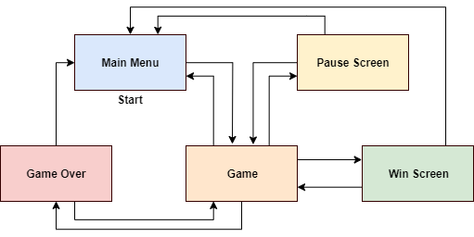

**Menu Screens**

Main Menu Screen Diagram

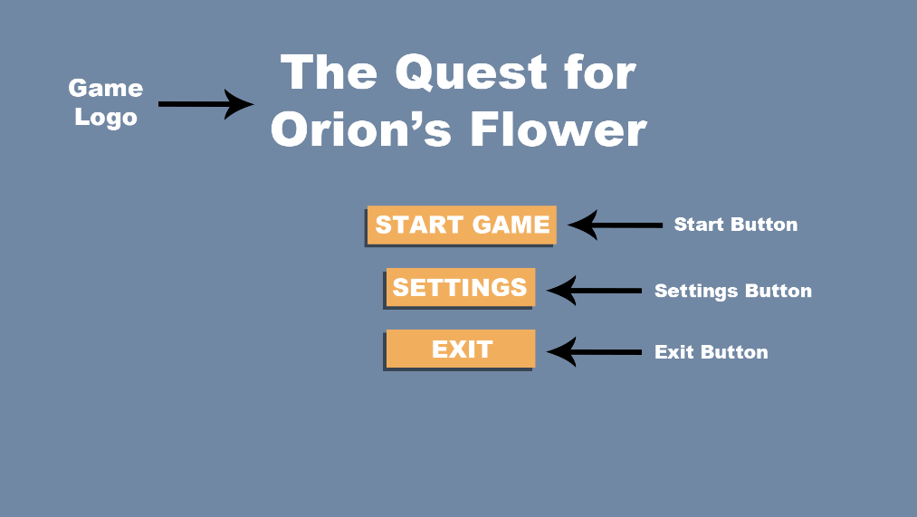

Main Menu Screen Description

**Start Game Button**

* This is used to load the game scene.

**Settings Button**

* The settings button will enter the settings menu.

**Exit Button**

* This will close the application.

Settings Menu Screen Diagram

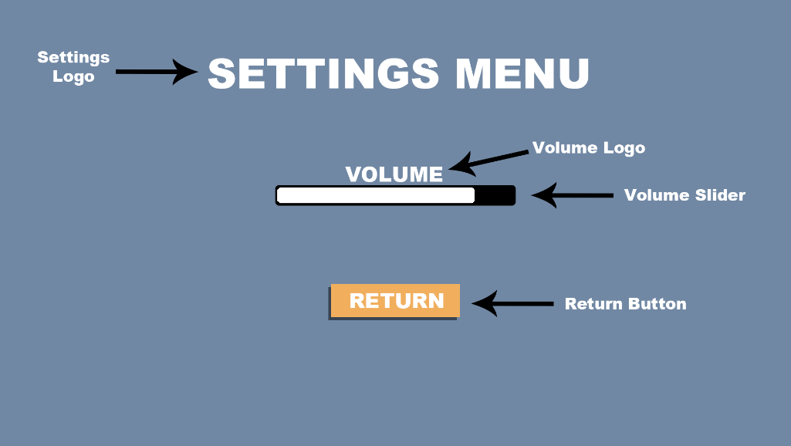

Settings Menu Screen Description

**Settings Menu Logo**

* Indicates the screen the user is on

**Volume Logo**

* Informs the user what the slider does

**Volume Slider**

* User can adjust volume slider.

**Return Button**

* The Return button takes the user back to the Main Menu.

Game Screen Design

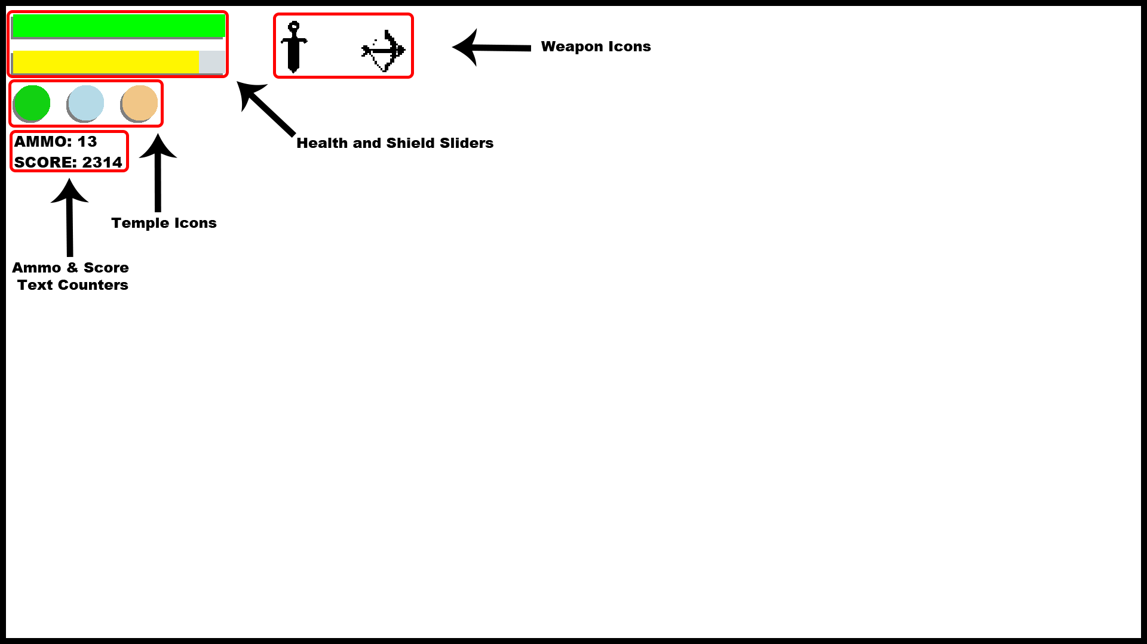

Game Screen Description

**Health Bar**

* Players current Health

**Shield Bar**

* Players current Shield

**Player Score**

* The Players current score

**Weapon Icons**

* The Sword and Bow Icons are used to notify when Weapon has been picked up.

**Temple Orbs**

* The Temple Orbs the Player has collected so far

Pause Screen Diagram

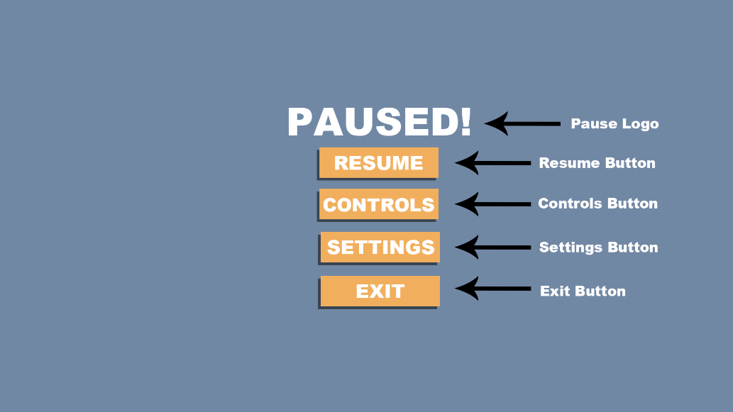

Pause Screen Description

**Pause Logo**

* Informs the user the game is Paused!

**Resume Button**

* Resumes the game

**Controls Button**

* Displays a new screen to inform user about the game’s controls

**Settings Button**

* Displays a new screen which allows the user to change the volume

**Exit Button**

* Exits to the Main Menu

Pause Screen - Controls Diagram

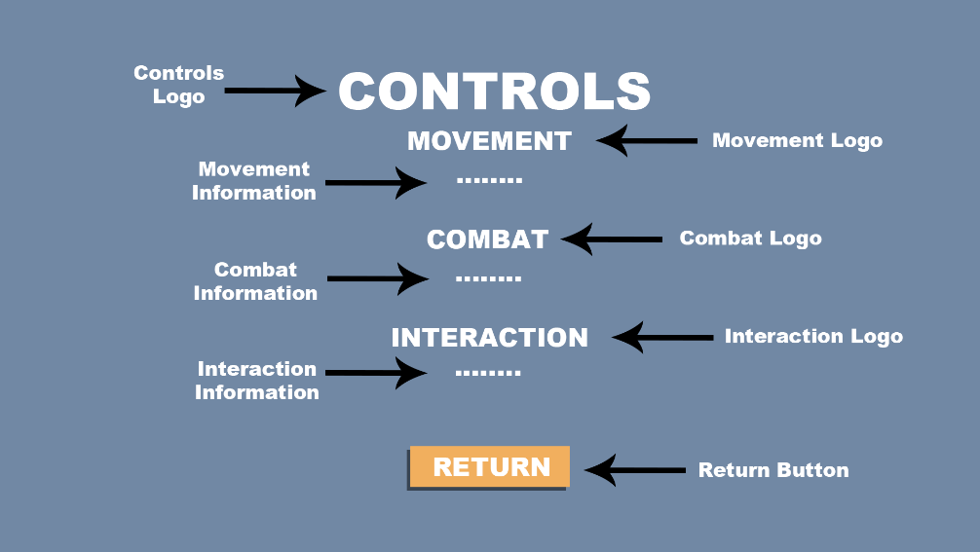

Pause Screen - Controls Description

**Controls Logo**

* Informs the user about the screen they are on

**Movement Logo**

* Informs them that this information covers Player Movement

**Movement Information**

* Displays information about Player Movement

**Combat Logo**

* Informs them that this information covers Player Combat

**Combat Information**

* Displays information about Player Combat

**Interaction Logo**

* Informs them that this information covers Player Interaction

**Interaction Information**

* Displays information about Player Interaction

**Return Button**

* Returns the player to the pause screen

Pause Screen - Settings Diagram

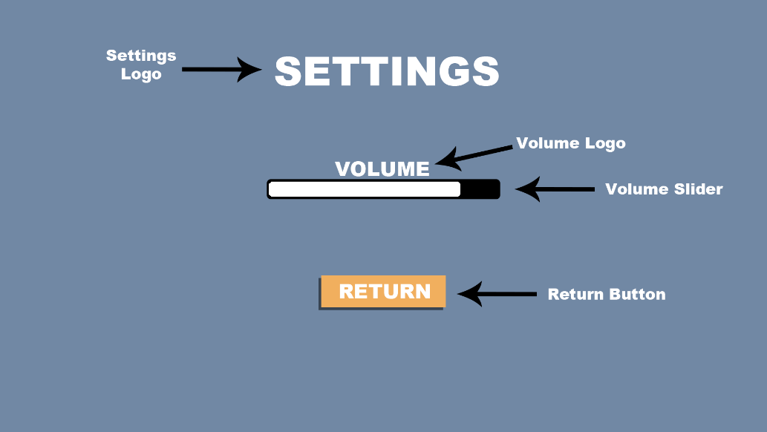

Pause Screen - Settings Description

**Settings Logo**

* Indicates the screen the user is on

**Volume Logo**

* Informs the user what the slider does

**Volume Slider**

* User can adjust volume slider.

**Return Button**

* The Return button takes the user back to the Main Menu.

Game Over Screen Diagram

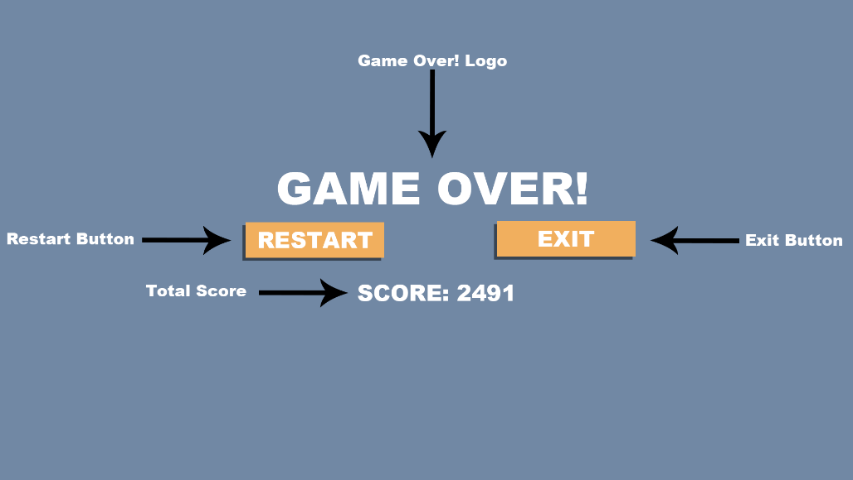

Game Over Screen Description

**Restart Button**

* Reloads the Game Scene

**Return button**

* Loads the Main Menu scene

**Players End Score**

* Displays the players final score when they lose

**GAME ELEMENTS**

**PLAYER CHARACTER**

|  |  |
| --- | --- |
| **Character Name** | **Graphics** |
| Clark |  |

|  |  |  |
| --- | --- | --- |
| **Settings** | | |
| **Properties** | **Description** | **Type** |
| Health | Players Health. The Game will end if the Players Health runs out! | Int |
| Shield | Players Shield. The Players Health will start to drain when the Shield runs out! | int |
| Speed | Players Movement Speed! | Float |

**WEAPONS**

|  |  |
| --- | --- |
| **Weapon Name** | **Graphics** |
| Orion’s Sword |  |

|  |  |  |
| --- | --- | --- |
| **Settings** | | |
| **Properties** | **Description** | **Type** |
| Damage | The amount of damage the weapon deals to Enemies! | int |
| Attack Counter | Time between attacks! | Float |
| Attack Time | The time the attack lasts! | Float |
| SwordPickup | When the Player collides with Sword, SwordPickup bool is set to true | bool |

|  |  |
| --- | --- |
| **Weapon Name** | **Graphics** |
| Orion’s Bow & Arrow |  |

|  |  |  |
| --- | --- | --- |
| **Settings** | | |
| **Properties** | **Description** | **Type** |
| Damage | The amount of damage the weapon deals to Enemies! | int |
| Arrow Speed | The speed in which the arrow reaches its destination! | Float |
| Fire Time | The time interval for when the bow can be fired! | Float |
| BowPickup | When the Player collides with Bow, BowPickup bool is set to true | bool |

**NPCs**

|  |  |
| --- | --- |
| **NPC Name** | **Graphics** |
| Dad |  |

|  |  |  |
| --- | --- | --- |
| **Settings** | | |
| **Properties** | **Description** | **Type** |
| ---- | The Dad NPC is used in order to provide Dialog for the Player and inform them about their quest | --- |

|  |  |
| --- | --- |
| **NPC Name** | **Graphics** |
| Mum |  |

|  |  |  |
| --- | --- | --- |
| **Settings** | | |
| **Properties** | **Description** | **Type** |
| ---- | The Mum NPC is used in order to provide Dialog for the Player and inform them about their quest | --- |

|  |  |
| --- | --- |
| **Dialog Name** | **Graphics** |
| DialogBox |  |

|  |  |  |
| --- | --- | --- |
| **Settings** | | |
| **Properties** | **Description** | **Type** |
| ---- | The Dialog Box which is used as a backdrop for the text when speaking to an NPC | --- |

**ENEMIES**

|  |  |
| --- | --- |
| **Enemy Name** | **Graphics** |
| Slime – Red  Slime – Blue  Slime – Green |  |

|  |  |  |
| --- | --- | --- |
| **Settings** | | |
| **Properties** | **Description** | **Type** |
| Health | Skeleton’s Health, when the Skeleton’s Health reach “0” the Enemy will be destroyed! | int |
| Damage | When the Skeleton collides with the Player, they will deal a specific amount of damage! | int |
| Speed | This is the Skeleton’s movement speed! | Float |
| Reset Time | The time between enemy attacks! | Float |
| Min Range | The minimum range an enemy must be before following the Player! | Float |
| Max Range | The Maximum range an enemy must be before following the Player! | Float |
| Score | When the Skeleton is killed, the Player’s score will increase! | int |

|  |  |
| --- | --- |
| **Enemy Name** | **Graphics** |
| Skeleton |  |

|  |  |  |
| --- | --- | --- |
| **Settings** | | |
| **Properties** | **Description** | **Type** |
| Health | Skeleton’s Health, when the Skeleton’s Health reach “0” the Enemy will be destroyed! | int |
| Damage | When the Skeleton collides with the Player, they will  deal a specific amount of damage! | int |
| Speed | This is the Skeleton’s movement speed! | Float |
| Reset Time | The time between enemy attacks! | Float |
| Min Range | The minimum range an enemy must be before following the Player! | Float |
| Max Range | The Maximum range an enemy must be before following the Player! | Float |
| Score | When the Skeleton is killed, the Player’s score will increase! | int |

|  |  |
| --- | --- |
| **Enemy Name** | **Graphics** |
| Desert Mummy |  |

|  |  |  |
| --- | --- | --- |
| **Settings** | | |
| **Properties** | **Description** | **Type** |
| Health | Skeleton’s Health, when the Skeleton’s Health reach “0” the Enemy will be destroyed! | int |
| Damage | When the Skeleton collides with the Player, they will deal a specific amount of damage! | int |
| Speed | This is the Skeleton’s movement speed! | Float |
| Reset Time | The time between enemy attacks! | Float |
| Min Range | The minimum range an enemy must be before following the Player! | Float |
| Max Range | The Maximum range an enemy must be before following the Player! | Float |
| Score | When the Skeleton is killed, the Player’s score will increase! | int |

|  |  |
| --- | --- |
| **Enemy Name** | **Graphics** |
| Snowman |  |

|  |  |  |
| --- | --- | --- |
| **Settings** | | |
| **Properties** | **Description** | **Type** |
| Health | Skeleton’s Health, when the Skeleton’s Health reach “0” the Enemy will be destroyed! | int |
| Damage | When the Skeleton collides with the Player, they will deal a specific amount of damage! | int |
| Speed | This is the Skeleton’s movement speed! | Float |
| Reset Time | The time between enemy attacks! | Float |
| Min Range | The minimum range an enemy must be before following the Player! | Float |
| Max Range | The Maximum range an enemy must be before following the Player! | Float |
| Score | When the Skeleton is killed, the Player’s score will increase! | int |

**BLOCKS**

|  |  |
| --- | --- |
| **Block Name** | **Graphics** |
| Trees – 1, 2, 3  Snow Trees – 1, 2, 3 |  |

|  |  |  |
| --- | --- | --- |
| **Settings** | | |
| **Properties** | **Description** | **Type** |
| N/A | An Object which is used to decorate the world and block the Players and Enemies path. | --- |

|  |  |
| --- | --- |
| **Block Name** | **Graphics** |
| Rock – 1, 2, 3  Snow Rock – 1, 2, 3 |  |

|  |  |  |
| --- | --- | --- |
| **Settings** | | |
| **Properties** | **Description** | **Type** |
| N/A | An Object which is used to decorate the world and block the Players and Enemies path. | --- |

|  |  |
| --- | --- |
| **Block Name** | **Graphics** |
| Rock – 1, 2, 3  Snow Rock – 1, 2, 3  Desert Rocks – 1, 2 |  |

|  |  |  |
| --- | --- | --- |
| **Settings** | | |
| **Properties** | **Description** | **Type** |
| N/A | An Object which is used to decorate the world and block the Players and Enemies path. | --- |

|  |  |
| --- | --- |
| **Block Name** | **Graphics** |
| Fences – 1, 2, 3  Fence Pillar |  |

|  |  |  |
| --- | --- | --- |
| **Settings** | | |
| **Properties** | **Description** | **Type** |
| N/A | An Object which is used to decorate the world and block the Players and Enemies path. | --- |

|  |  |
| --- | --- |
| **Block Name** | **Graphics** |
| Cacti – 1, 2 |  |

|  |  |  |
| --- | --- | --- |
| **Settings** | | |
| **Properties** | **Description** | **Type** |
| N/A | An Object which is used to decorate the world and block the Players and Enemies path. | --- |

|  |  |
| --- | --- |
| **Block Name** | **Graphics** |
| Dungeon Walls Set – 1  Dungeon Walls Set - 2 |  |

|  |  |  |
| --- | --- | --- |
| **Settings** | | |
| **Properties** | **Description** | **Type** |
| N/A | An Object which is used to decorate the dungeons and block the Player and Enemies. | --- |

|  |  |
| --- | --- |
| **Block Name** | **Graphics** |
| Crate |  |

|  |  |  |
| --- | --- | --- |
| **Settings** | | |
| **Properties** | **Description** | **Type** |
| N/A | A Physics Object which is used to decorate the world and allows the Player to push it onto buttons to solve puzzles, but also block the Player and Enemies. | --- |

|  |  |
| --- | --- |
| **Block Name** | **Graphics** |
| DoorLocked |  |

|  |  |  |
| --- | --- | --- |
| **Settings** | | |
| **Properties** | **Description** | **Type** |
| LockedDoor | Prevents/Blocks the Player from progressing in the Dungeon unless they pick up the key, then the GameObject is set to false | GameObject |

|  |  |
| --- | --- |
| **Block Name** | **Graphics** |
| DoorUnlocked |  |

|  |  |  |
| --- | --- | --- |
| **Settings** | | |
| **Properties** | **Description** | **Type** |
| N/A | DoorUnlocked is used to give the ability to leave a dungeon, it acts as a trigger and teleports them out of the dungeon | --- |

|  |  |
| --- | --- |
| **Block Name** | **Graphics** |
| Stone Barrier |  |

|  |  |  |
| --- | --- | --- |
| **Settings** | | |
| **Properties** | **Description** | **Type** |
| Barrier | The Stone Barrier blocks the Player from proceeding in the Dungeon. When the Player triggers a button the Barrier GameObject will be set to false and the Player can pass | GameObject |

**PICKUPS**

|  |  |
| --- | --- |
| **Pickup Name** | **Graphics** |
| Health |  |

|  |  |  |
| --- | --- | --- |
| **Settings** | | |
| **Properties** | **Description** | **Type** |
| health | Health Pickup, when the Player collects a heart, it will increase their current hp | int |

|  |  |
| --- | --- |
| **Pickup Name** | **Graphics** |
| Shield |  |

|  |  |  |
| --- | --- | --- |
| **Settings** | | |
| **Properties** | **Description** | **Type** |
| shield | Shield Pickup, when the Player collects a Shield, it will increase their current shield | int |

|  |  |
| --- | --- |
| **Pickup Name** | **Graphics** |
| Ammo |  |

|  |  |  |
| --- | --- | --- |
| **Settings** | | |
| **Properties** | **Description** | **Type** |
| ammo | Ammo, when the Player collects Ammo, the amount of ammo they have increases | int |

|  |  |
| --- | --- |
| **Pickup Name** | **Graphics** |
| Coin |  |

|  |  |  |
| --- | --- | --- |
| **Settings** | | |
| **Properties** | **Description** | **Type** |
| score | Coin Score, When the Player collects a coin, the Players score is increased | int |

**PUZZLE ITEMS AND OBJECTS**

|  |  |
| --- | --- |
| **Puzzle Name** | **Graphics** |
| Forest Key |  |

|  |  |  |
| --- | --- | --- |
| **Settings** | | |
| **Properties** | **Description** | **Type** |
| ForestKey | When Player picks up the Forest Key, the ForestKey bool is set to true and they can access the Forest Temple | bool |

|  |  |
| --- | --- |
| **Puzzle Name** | **Graphics** |
| Frost Key |  |

|  |  |  |
| --- | --- | --- |
| **Settings** | | |
| **Properties** | **Description** | **Type** |
| FrostKey | When Player picks up the Frost Key, the FrostKey bool is set to true and they can access the Frost Temple | bool |

|  |  |
| --- | --- |
| **Puzzle Name** | **Graphics** |
| Desert Key |  |

|  |  |  |
| --- | --- | --- |
| **Settings** | | |
| **Properties** | **Description** | **Type** |
| DesertKey | When Player picks up the Desert Key, the DesertKey bool is set to true and they can access the Desert Temple | bool |

|  |  |
| --- | --- |
| **Puzzle Name** | **Graphics** |
| Gold Key |  |

|  |  |  |
| --- | --- | --- |
| **Settings** | | |
| **Properties** | **Description** | **Type** |
| GoldKey | When Player picks up the Gold Key, this triggers the LockedDoor GameObject to be false and the OpenDoor GameObject to be true | GameObject |

|  |  |
| --- | --- |
| **Object Name** | **Graphics** |
| DoorOpen |  |

|  |  |  |
| --- | --- | --- |
| **Settings** | | |
| **Properties** | **Description** | **Type** |
| OpenDoor | When the Player acquires the Gold Key the Locked Door GameObject is set to false and the OpenDoor GameObject is set to true | GameObject |

|  |  |
| --- | --- |
| **Puzzle Name** | **Graphics** |
| Forest Orb |  |

|  |  |  |
| --- | --- | --- |
| **Settings** | | |
| **Properties** | **Description** | **Type** |
| ForestOrb | When Player picks up the Forest Orb, the ForestOrb bool is set to true | bool |

|  |  |
| --- | --- |
| **Puzzle Name** | **Graphics** |
| Frost Orb |  |

|  |  |  |
| --- | --- | --- |
| **Settings** | | |
| **Properties** | **Description** | **Type** |
| FrostOrb | When Player picks up the Frost Orb, the FrostOrb bool is set to true | bool |

|  |  |
| --- | --- |
| **Puzzle Name** | **Graphics** |
| Desert Orb |  |

|  |  |  |
| --- | --- | --- |
| **Settings** | | |
| **Properties** | **Description** | **Type** |
| DesertOrb | When Player picks up the Desert Orb, the DesertOrb bool is set to true | bool |

|  |  |
| --- | --- |
| **Puzzle Name** | **Graphics** |
| Button |  |

|  |  |  |
| --- | --- | --- |
| **Settings** | | |
| **Properties** | **Description** | **Type** |
| ---- | When the Player and or Crate collides with a button it will activate a trigger and destroy a corresponding barrier GameObject | --- |

|  |  |
| --- | --- |
| **Puzzle Name** | **Graphics** |
| Orion’s Flower |  |

|  |  |  |
| --- | --- | --- |
| **Settings** | | |
| **Properties** | **Description** | **Type** |
| OrionFlower | When the Player collides with Orion’s Flower, it will set the OrionFlower bool to true | bool |

**ENVIRONMENT ASSETS**

|  |  |
| --- | --- |
| **Asset Name** | **Graphics** |
| Bush – 1  Bush - 2 |  |

|  |  |  |
| --- | --- | --- |
| **Settings** | | |
| **Properties** | **Description** | **Type** |
| ---- | Bushes are used to decorate the Forest Area; the Player can walk through these | --- |

|  |  |
| --- | --- |
| **Asset Name** | **Graphics** |
| Mushroom - 1  Mushroom - 1 |  |

|  |  |  |
| --- | --- | --- |
| **Settings** | | |
| **Properties** | **Description** | **Type** |
| ---- | Mushrooms are used to decorate the Forest Area; the Player can walk through these | --- |

|  |  |
| --- | --- |
| **Asset Name** | **Graphics** |
| Snow Mound -1  Snow Mound - 2 |  |

|  |  |  |
| --- | --- | --- |
| **Settings** | | |
| **Properties** | **Description** | **Type** |
| ---- | Snow Mounds are used to decorate the Snow Area, the Player can walk through these. | --- |

|  |  |
| --- | --- |
| **Asset Name** | **Graphics** |
| Snow Mushroom - 1  Snow Mushroom - 2 |  |

|  |  |  |
| --- | --- | --- |
| **Settings** | | |
| **Properties** | **Description** | **Type** |
| ---- | Snow Mushrooms are used to decorate the Snow Area, the Player can walk through these. | --- |

|  |  |
| --- | --- |
| **Asset Name** | **Graphics** |
| Desert Grass – 1  Desert Grass - 2 |  |

|  |  |  |
| --- | --- | --- |
| **Settings** | | |
| **Properties** | **Description** | **Type** |
| ---- | Desert Grass is used to decorate the Desert Area, the Player can walk through these. | --- |

|  |  |
| --- | --- |
| **Asset Name** | **Graphics** |
| Skull |  |

|  |  |  |
| --- | --- | --- |
| **Settings** | | |
| **Properties** | **Description** | **Type** |
| ---- | The Skull is used to decorate the Desert Area, the Player can walk through them. | --- |

**BUILDINGS**

|  |  |
| --- | --- |
| **Building Name** | **Graphics** |
| Forest Temple |  |

|  |  |  |
| --- | --- | --- |
| **Settings** | | |
| **Properties** | **Description** | **Type** |
| ---- | The Forest Temple allows the Player to access the Forest Dungeon, it uses a trigger and teleports them to the dungeon. | --- |

|  |  |
| --- | --- |
| **Building Name** | **Graphics** |
| Snow Temple |  |

|  |  |  |
| --- | --- | --- |
| **Settings** | | |
| **Properties** | **Description** | **Type** |
| ---- | The Snow Temple allows the Player to access the Snow Dungeon, it uses a trigger and teleports them to the dungeon. | --- |

|  |  |
| --- | --- |
| **Building Name** | **Graphics** |
| Desert Temple |  |

|  |  |  |
| --- | --- | --- |
| **Settings** | | |
| **Properties** | **Description** | **Type** |
| ---- | The Desert Temple allows the Player to access the Desert Dungeon, it uses a trigger and teleports them to the dungeon. | --- |

|  |  |
| --- | --- |
| **Building Name** | **Graphics** |
| Ancient Temple |  |

|  |  |  |
| --- | --- | --- |
| **Settings** | | |
| **Properties** | **Description** | **Type** |
| ---- | The Ancient Temple allows the Player to access the Ancient Dungeon, it uses a trigger and teleports them to the dungeon. | --- |

|  |  |
| --- | --- |
| **Building Name** | **Graphics** |
| Home |  |

|  |  |  |
| --- | --- | --- |
| **Settings** | | |
| **Properties** | **Description** | **Type** |
| ---- | The Main House is used to complete the game, it acts as a trigger, when the Player triggers it, the Win Screen will display and inform the Player they have won. | --- |

**TILE SETS**

|  |  |
| --- | --- |
| **Tile Name** | **Graphics** |
| Forest Tile Set – 1  Forest Tile Set – 2  Forest Tile Set – 3  Forest Tile Set – 4  Forest Tile Set – 5  Forest Tile Set – 6  Forest Tile Set – 7  Forest Tile Set – 8  Forest Tile Set – 9  Forest Tile Set - 10 |  |

|  |  |  |
| --- | --- | --- |
| **Settings** | | |
| **Properties** | **Description** | **Type** |
| N/A | Tile Sets used for the Forest Area, these make up the grass and pathways. | --- |

|  |  |
| --- | --- |
| **Tile Name** | **Graphics** |
| Snow Tile Set – 1  Snow Tile Set – 2  Snow Tile Set – 3  Snow Tile Set – 4  Snow Tile Set – 5  Snow Tile Set – 6  Snow Tile Set – 7  Snow Tile Set – 8  Snow Tile Set – 9  Snow Tile Set - 10 |  |

|  |  |  |
| --- | --- | --- |
| **Settings** | | |
| **Properties** | **Description** | **Type** |
| N/A | Tile Sets used for the Snow Area, these make up the grass and pathways. | --- |

|  |  |
| --- | --- |
| **Tile Name** | **Graphics** |
| Desert Tile Set – 1  Desert Tile Set – 2  Desert Tile Set – 3  Desert Tile Set – 4  Desert Tile Set – 5  Desert Tile Set – 6  Desert Tile Set – 7  Desert Tile Set – 8  Desert Tile Set – 9  Desert Tile Set - 10 |  |

|  |  |  |
| --- | --- | --- |
| **Settings** | | |
| **Properties** | **Description** | **Type** |
| N/A | Tile Sets used for the Desert Area, these make up the sand and pathways. | --- |

|  |  |
| --- | --- |
| **Tile Name** | **Graphics** |
| Forest Dungeon Tile Set – 1  Forest Dungeon Tile Set – 2  Forest Dungeon Tile Set – 3 |  |

|  |  |  |
| --- | --- | --- |
| **Settings** | | |
| **Properties** | **Description** | **Type** |
| N/A | Tile Sets used for the Forest Dungeon, this makes the pathways of the dungeon | --- |

|  |  |
| --- | --- |
| **Tile Name** | **Graphics** |
| Snow Dungeon Tile Set – 1  Snow Dungeon Tile Set – 2  Snow Dungeon Tile Set – 3 |  |

|  |  |  |
| --- | --- | --- |
| **Settings** | | |
| **Properties** | **Description** | **Type** |
| N/A | Tile Sets used for the Snow Dungeon, this makes the pathways of the dungeon | --- |

|  |  |
| --- | --- |
| **Tile Name** | **Graphics** |
| Desert Dungeon Tile Set – 1  Desert Dungeon Tile Set – 2  Desert Dungeon Tile Set – 3 |  |

|  |  |  |
| --- | --- | --- |
| **Settings** | | |
| **Properties** | **Description** | **Type** |
| N/A | Tile Sets used for the Desert Dungeon, this makes the pathways of the dungeon | --- |

|  |  |
| --- | --- |
| **Level Plan** | |
| **Key** | **Name** |
|  | Player Character |
|  | Non-Player-Character |
|  | Enemy |
|  | Boss |
|  | Temple |
|  | Home |
|  | Key |
|  | Temple Key |
|  | Coin |
|  | Ammo |
|  | Crate |
|  | Button |
|  | Weapon |
|  | Shield |
|  | Health |
|  | Stone Barrier |
|  | Locked Door |
|  | Entrance |

**Level Diagrams**

Main Area

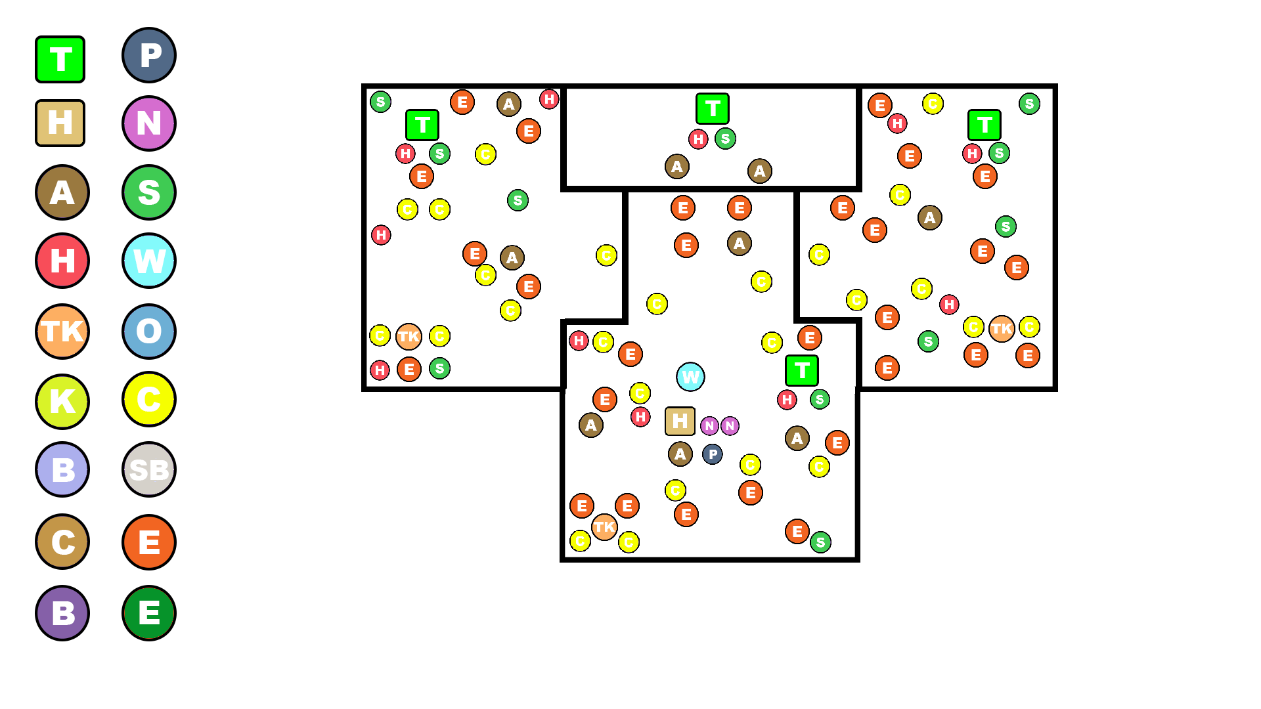

Forest Dungeon

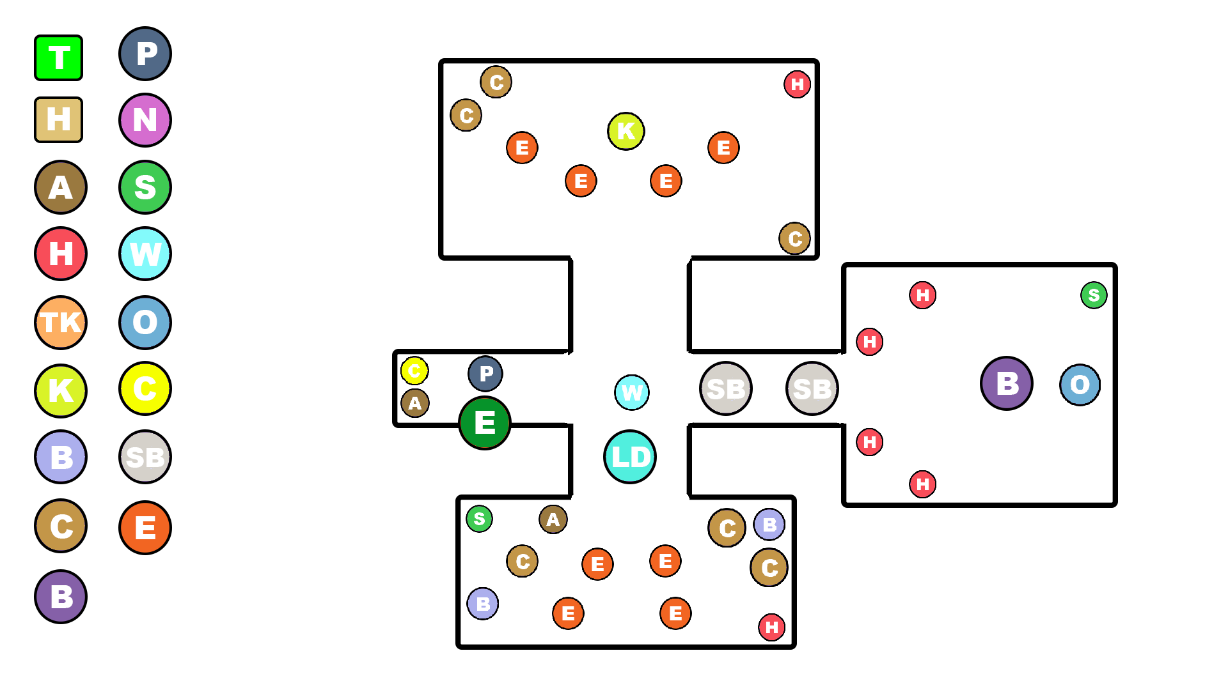

Frost Dungeon

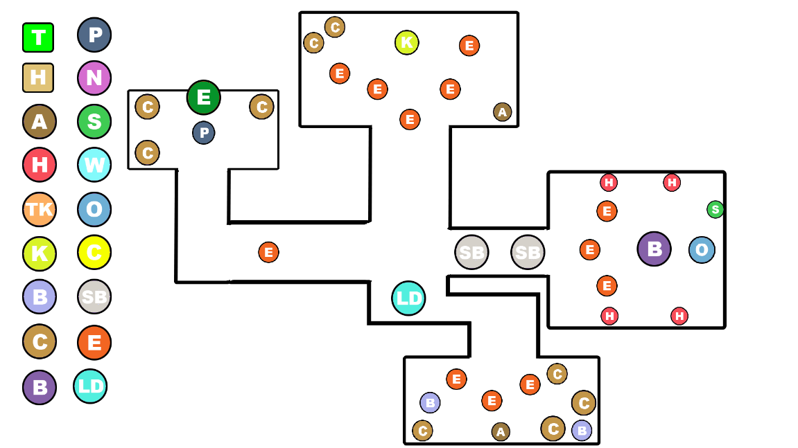

Desert Dungeon

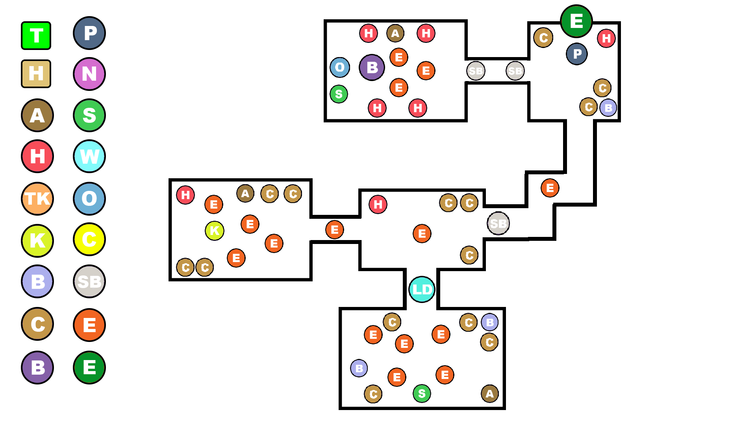

Ancient Dungeon

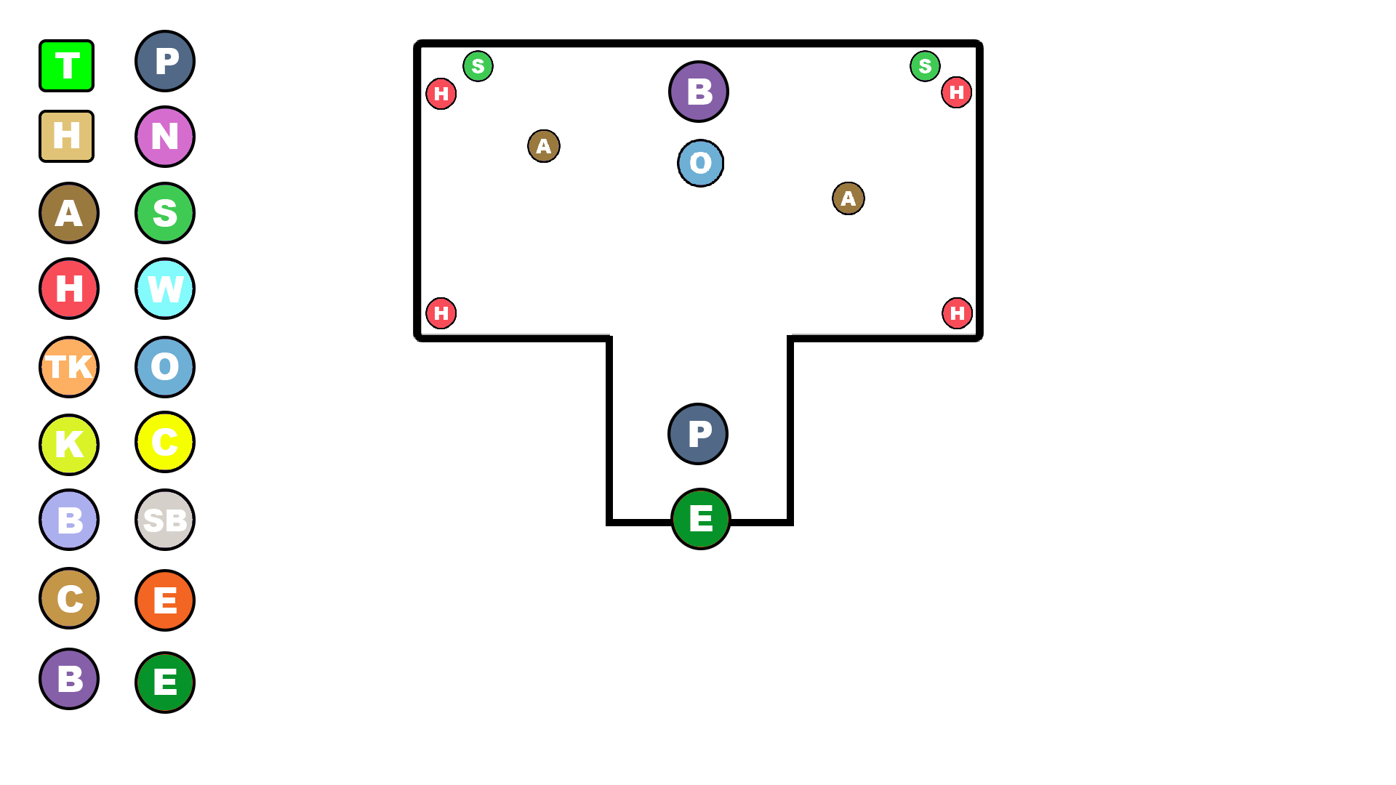

**Game Breakdown**

Space

Top Down/Bounded/Camera

* Follows player on Horizontal and Vertical

**Rules**

Player

* Player loses Health when hit by an enemy and when Shield is empty
* Player loses Shield when hit by an enemy
* Game is over when player loses all health
* Game is Won when Player gets Orion’s Flower and enters the Main House

Arrow

* Dies when hitting an Enemy or Object
* Dies after a short time

Enemies

* Enemies lose health when hit by the Players Arrows or Sword
* Increases Player Score when Enemy is killed

Goal

* The Players goal is to find Orion’s Flower and break the family curse. They must fight their way through multiple dungeons to collect the temple orbs. Once the Player has collected all 3 orbs, they can access the Final Ancient Temple and fight the Ancient Being. Once he has been defeated, they can collect Orion’s Flower, return Home and beat the game!

Mechanics

* Player can run around the map
* Firing Arrows – Ranged Combat
* Swing Sword – Melee Combat
* Avoid Enemies
* Complete Puzzles
* Collect Pickups – Coins, Health, Shield and Ammo

In Game Controls

Keys

* W - Move Up
* S - Move Down
* A - Move Left
* D - Move right
* Space – Enter Temples
* ESC – Pause Game

Mouse

* Left Click – Melee Attack
* Right Click – Ranged Attack

|  |  |
| --- | --- |
| **Demo or Die Feedback** | |
| **Feedback** | **Improvements** |
| No problems, Bullets shot out of both guns. Health is incredibly high considering how slow the zombies are. The player can walk into the void and the camera is a bit slow considering the speed of the player. | * Enemy Movement Speed has been increased! * Added Edge Colliders to the world to prevent the Player from leaving the area! * Camera Speed has increased and stays on top of the Player! |
| Nothing happens when health is depleted; And there is no border/barrier on the edge of the map to keep the player from moving out by mistake. Other than that, everything works to a good standard | * Player now Dies when Health is fully depleted! * Added Edge Colliders to the world to prevent the Player from leaving the area! |
| Player can go out of bounds, and camera moves slower than the player does, meaning you can disappear from frame. Spawn point is the same for all, so worth randomizing a little if you can. Character doesn't die, so worth working on that. I like that it shoots from both barrels of the gun, maybe worth moving that to an upgrade system? | * Added Edge Colliders to the world to prevent the Player from leaving the area! * Camera Speed has increased and stays on top of the Player! * Enemies have been specifically placed in specific areas of the map! * Player now Dies when Health is fully depleted! |
| love the 2 bullets out of 2 guns, can go out the map. no pause menu or game over screen. camera lags a little bit causing the player to go off screen. | * Added Edge Colliders to the world to prevent the Player from leaving the area! * Added Pause Menu and Game Over Screen! * Camera Speed has increased and stays on top of the Player! |
| Camera speed is a little too slow, allowing the player to go off camera. This should be sped up a little. Zombies are ridiculously slow. Makes for a game which is not so challenging. | * Camera Speed has increased and stays on top of the Player! * Enemy Speed has been increased! |

**Press Kit**

**Store icon/Logo**



**Core features**

* Top down Gameplay
* Melee Combat
* Ranged Combat
* Exploration
* Interact with NPCs
* Puzzles
* Boss Fights
* Temples/Dungeons
* Item Pickups

**Screenshots**

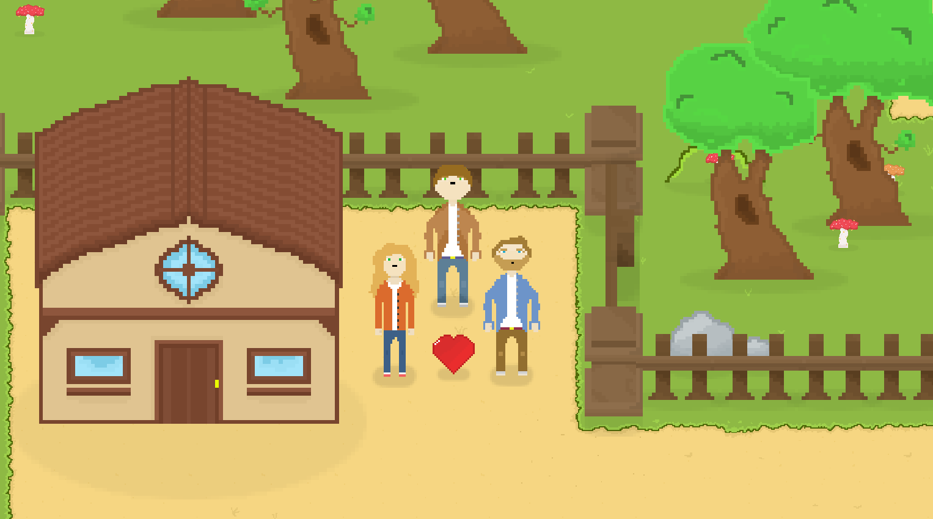

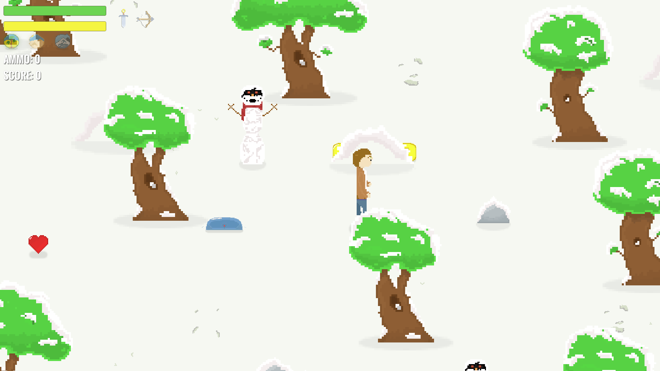

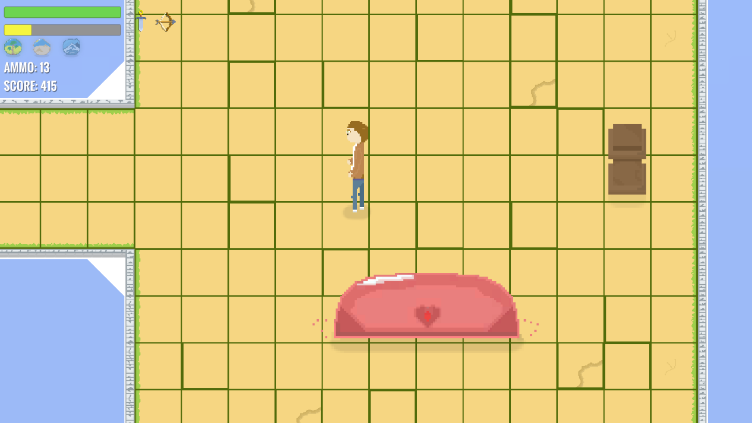

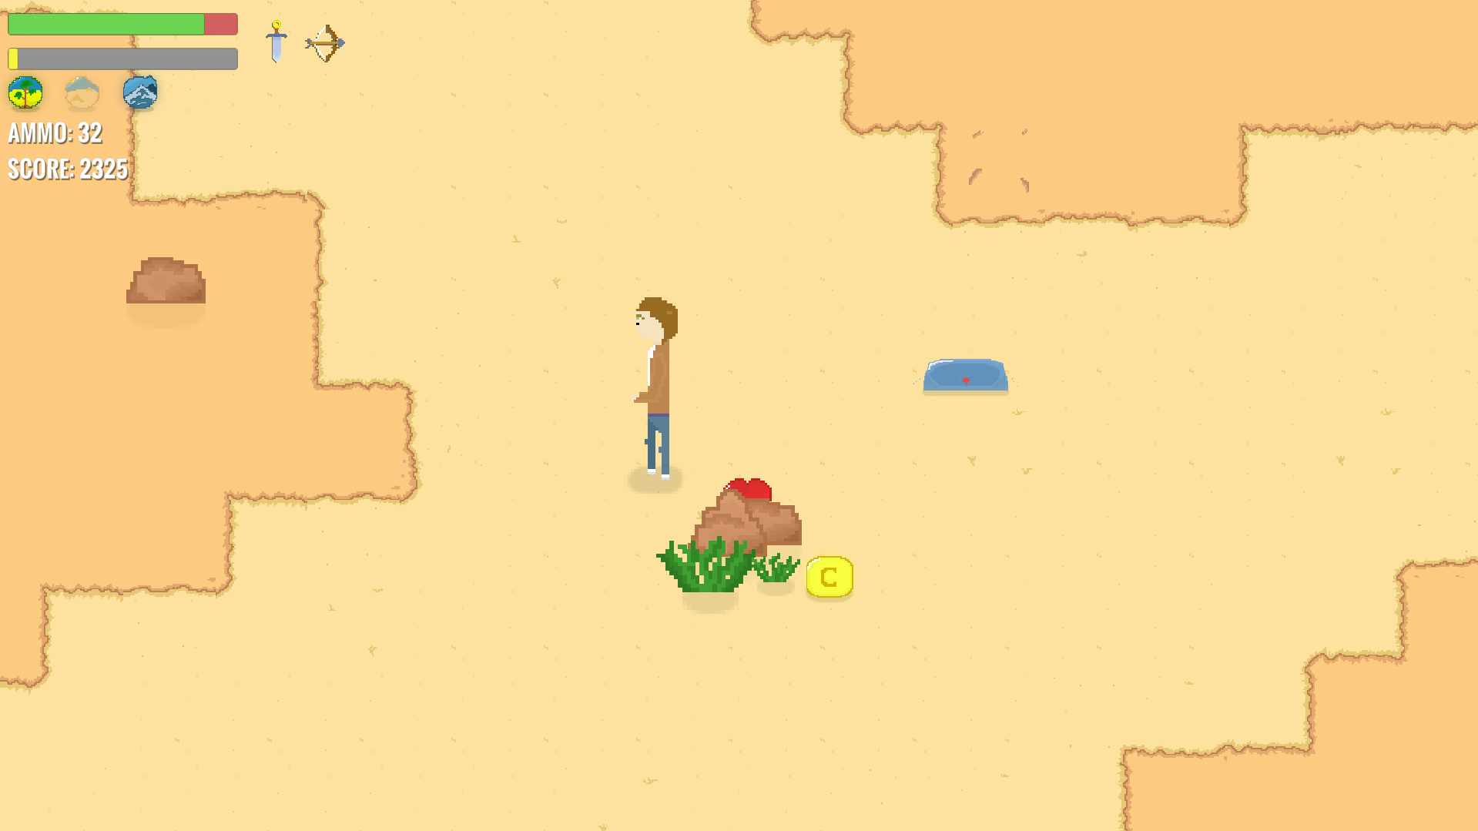

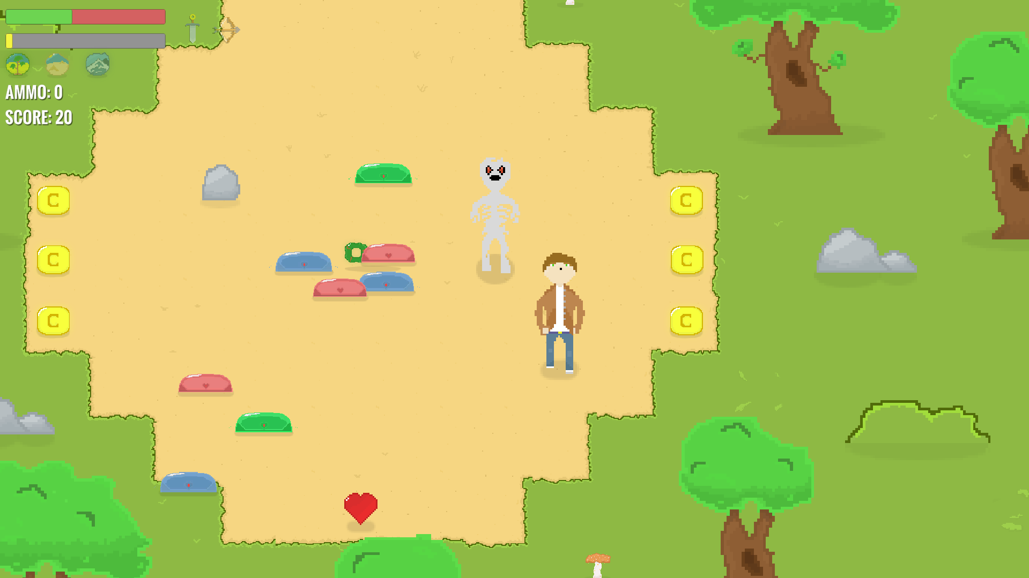

**Rating**



**Similar games**

**Game name**

Shalnor Legends: Sacred Lands

**Game link**

<https://store.steampowered.com/app/651680/Shalnor_Legends_Sacred_Lands/>

**Description of similar features**

* Top down view
* Melee and Ranged Combat
* Open World Exploration
* Dungeons

YouTube Review Channels

<https://www.youtube.com/user/cublikefoot/videos>